**Elementary data link layer protocols**

Elementary Data Link protocols are classified into three categories, as given below −

* Protocol 1 − Unrestricted simplex protocol
* Protocol 2 − Simplex stop and wait protocol
* Protocol 3 − Simplex protocol for noisy channels.

Let us discuss each protocol one by one.

## **Unrestricted Simplex Protocol**

Data transmitting is carried out in one direction only. The transmission (Tx) and receiving (Rx) are always ready and the processing time can be ignored. In this protocol, infinite buffer space is available, and no errors are occurring that is no damage frames and no lost frames.

The Unrestricted Simplex Protocol is diagrammatically represented as follows −

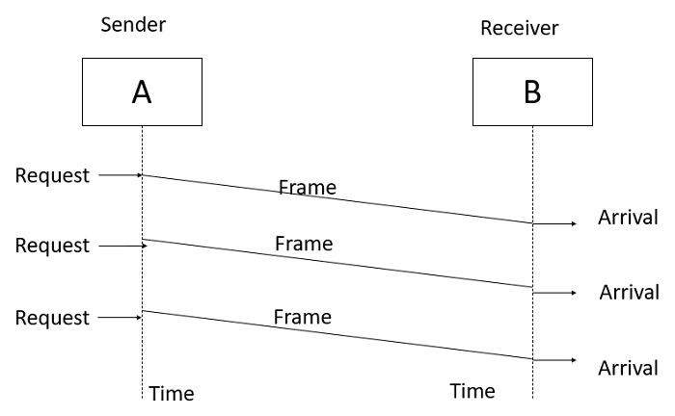

## **Simplex Stop and Wait protocol**

In this protocol we assume that data is transmitted in one direction only. No error occurs; the receiver can only process the received information at finite rate. These assumptions imply that the transmitter cannot send frames at rate faster than the receiver can process them.

The main problem here is how to prevent the sender from flooding the receiver. The general solution for this problem is to have the receiver send some sort of feedback to sender, the process is as follows −

**Step1** − The receiver send the acknowledgement frame back to the sender telling the sender that the last received frame has been processed and passed to the host.

**Step 2** − Permission to send the next frame is granted.

**Step 3** − The sender after sending the sent frame has to wait for an acknowledge frame from the receiver before sending another frame.

This protocol is called Simplex Stop and wait protocol, the sender sends one frame and waits for feedback from the receiver. When the ACK arrives, the sender sends the next frame.

The Simplex Stop and Wait Protocol is diagrammatically represented as follows −

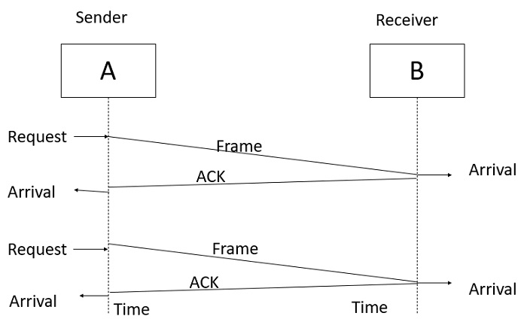

## **Simplex Protocol for Noisy Channel**

Data transfer is only in one direction, consider separate sender and receiver, finite processing capacity and speed at the receiver, since it is a noisy channel, errors in data frames or acknowledgement frames are expected. Every frame has a unique sequence number.

After a frame has been transmitted, the timer is started for a finite time. Before the timer expires, if the acknowledgement is not received , the frame gets retransmitted, when the acknowledgement gets corrupted or sent data frames gets damaged, how long the sender should wait to transmit the next frame is infinite.

The Simplex Protocol for Noisy Channel is diagrammatically represented as follows −

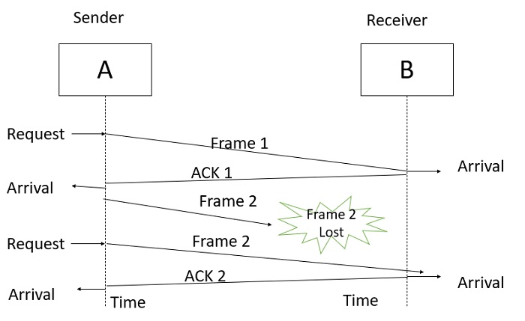

# Data Link Layer Protocols

[Data Link Layer](https://www.geeksforgeeks.org/design-issues-in-data-link-layer/) protocols are generally responsible to simply ensure and confirm that the bits and bytes that are received are identical to the bits and bytes being transferred. It is basically a set of specifications that are used for implementation of data link layer just above the physical layer of the [Open System Interconnections (OSI) Model](https://www.geeksforgeeks.org/osi-full-form/).

**Some Common Data Link Protocols:**

There are various data link protocols that are required for [Wide Area Network (WAN)](https://www.geeksforgeeks.org/wan-full-form/) and modem connections. Logical Link Control (LLC) is a data link protocol of [Local Area Network (LAN)](https://www.geeksforgeeks.org/types-of-area-networks-lan-man-and-wan/). Some of data link protocols are given below:

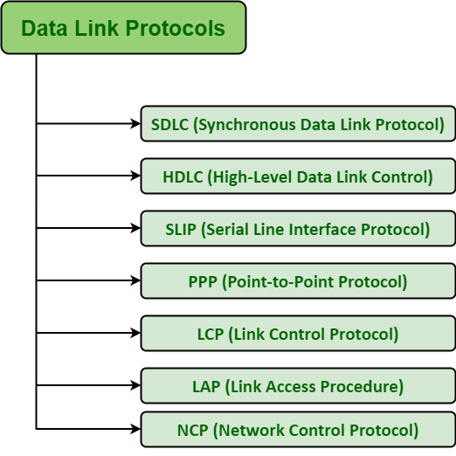

1. [Synchronous Data Link Protocol (SDLC)](https://www.geeksforgeeks.org/sdlc-types-and-topologies/)**–**

SDLC is basically a communication protocol of computer. It usually supports multipoint links even error recovery or error correction also. It is usually used to carry SNA (Systems Network Architecture) traffic and is present precursor to HDLC. It is also designed and developed by IBM in 1975. It is also used to connect all of the remote devices to mainframe computers at central locations may be in point-to-point (one-to-one) or point-to-multipoint (one-to-many) connections. It is also used to make sure that the data units should arrive correctly and with right flow from one network point to next network point.

1. [High-Level Data Link Protocol (HDLC)](https://www.geeksforgeeks.org/basic-frame-structure-of-hdlc/)**–**

HDLC is basically a protocol that is now assumed to be an umbrella under which many Wide Area protocols sit. It is also adopted as a part of X.25 network. It was originally created and developed by ISO in 1979. This protocol is generally based on SDLC. It also provides best-effort unreliable service and also reliable service. HDLC is a bit-oriented protocol that is applicable for point-to-point and multipoint communications both.

1. [Serial Line Interface Protocol (SLIP)](https://www.geeksforgeeks.org/slip-full-form/)**–**

SLIP is generally an older protocol that is just used to add a framing byte at end of IP packet. It is basically a data link control facility that is required for transferring IP packets usually among Internet Service Providers (ISP) and a home user over a dial-up link. It is an encapsulation of the TCP/IP especially designed to work with over serial ports and several router connections simply for communication. It is some limitations like it does not provide mechanisms such as error correction or error detection.

1. [Point to Point Protocol (PPP)](https://www.geeksforgeeks.org/ppp-full-form/)**–**

PPP is a protocol that is basically used to provide same functionality as SLIP. It is most robust protocol that is used to transport other types of packets also along with IP Packets. It can also be required for dial-up and leased router-router lines. It basically provides framing method to describe frames. It is a character-oriented protocol that is also used for error detection. It is also used to provides two protocols i.e. NCP and LCP. LCP is used for bringing lines up, negotiation of options, bringing them down whereas NCP is used for negotiating network-layer protocols. It is required for same serial interfaces like that of HDLC.

1. **Link Control Protocol (LCP) –**

It was originally developed and created by IEEE 802.2. It is also used to provide HDLC style services on LAN (Local Area Network). LCP is basically a PPP protocol that is used for establishing, configuring, testing, maintenance, and ending or terminating links for transmission of data frames.

1. **Link Access Procedure (LAP) –**

LAP protocols are basically a data link layer protocols that are required for framing and transferring data across point-to-point links. It also includes some reliability service features. There are basically three types of LAP i.e. LAPB (Link Access Procedure Balanced), LAPD (Link Access Procedure D-Channel), and LAPF (Link Access Procedure Frame-Mode Bearer Services). It is actually originated from IBM SDLC, which is being submitted by IBM to the ISP simply for standardization.

1. **Network Control Protocol (NCP) –**

NCP was also an older protocol that was implemented by ARPANET. It basically allows users to have access to use computers and some of the devices at remote locations and also to transfer files among two or more computers. It is generally a set of protocols that is forming a part of PPP. NCP is always available for each and every higher-layer protocol that is supported by PPP. NCP was replaced by TCP/IP in the 1980s.